 Emergency Medical Services Education

September 2025

⚠

Red Flags in Common Clinical Presentations

**Paramedic Student Teaching Module**

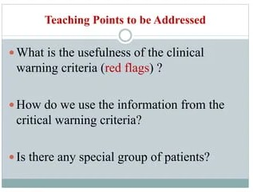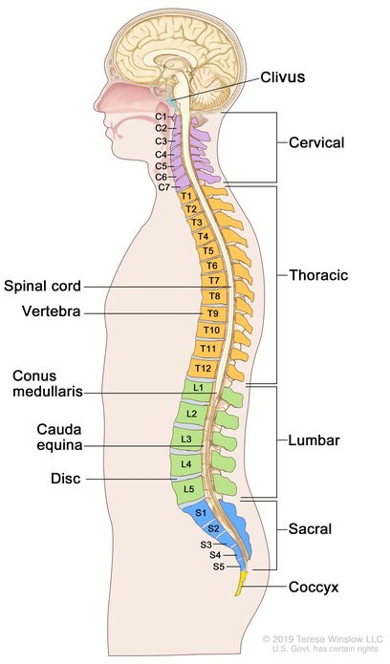

 **Example: Thunderclap Headache**

⚠ **Definition**

**Warning signs** that suggest a potentially serious underlying condition requiring urgent medical attention

**Clinical indicators** that differentiate emergent from non-emergent presentations

**Critical findings** that may not be immediately obvious but signal increased patient risk

⇧ **How They Guide Paramedic Decision-Making**

Determine **transport priority** and destination selection Guide **field interventions** and treatment protocols

Inform **hospital notifications** (stroke alerts, STEMI activation) Focus **assessment and documentation** on critical findings

**What Are Red Flags?**

Foundation for Clinical Assessment in Emergency Medicine

 **Importance in Emergency Medicine**

Early recognition of life-threatening conditions

Reduction of morbidity and mortality through prompt intervention Appropriate resource allocation and hospital preparation

**Red Flag:** "Worst headache of life" with sudden onset **Clinical Significance:** Potential subarachnoid hemorrhage

**Paramedic Actions:**

Initiate stroke alert protocol Rapid transport to stroke center

Document time of onset and symptoms

⇧ **Syncope**

Warning signs of cardiovascular collapse and

cerebral hypoperfusion

⚠ Early recognition of red flags saves lives

Paramedic Student Teaching Module

# Clinical Presentations: Red Flag Overview

Recognizing critical warning signs in common emergency presentations

 **Low Back Pain**

Critical warning signs of spinal pathology

requiring urgent intervention

 **Neck Pain**

Indications of potential cervical instability

and neurological compromise

 **Headache**

Warning signs of life-threatening intracranial

pathology

 **Chest Pain**

Indicators of cardiac emergencies requiring

immediate intervention

 **Abdominal Pain**

Signs of surgical emergencies and acute

abdomen requiring rapid transport

 **Altered Mental Status**

Critical indicators of neurological

emergencies and metabolic crises

⚠ Early recognition improves patient outcomes

Paramedic Student Teaching Module

# Low Back Pain: Red Flags

Critical Warning Signs

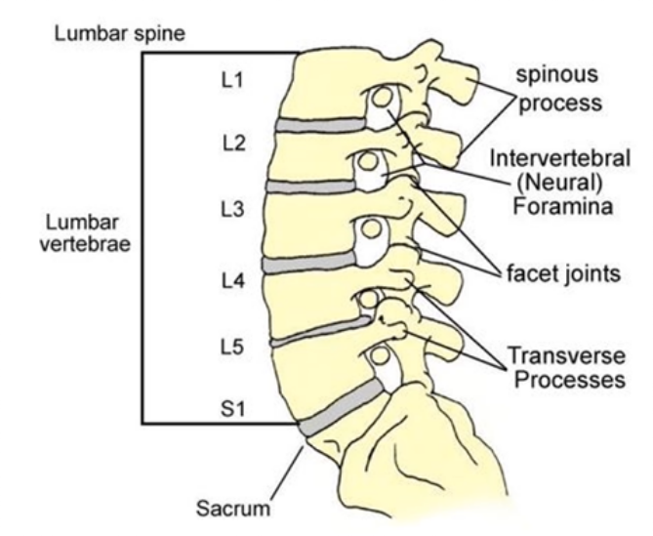

 Lumbar spine anatomy (L1-L5)

⚠

**History of cancer, unexplained weight loss, fever**

Clinical Significance: Possible spinal infection or malignancy Action: Document findings, notify receiving facility of concerns

⚠

**Recent trauma with pain**

Clinical Significance: Consider spinal fracture Action: Apply spinal motion restriction if indicated

⚠

**Progressive neurological deficit or saddle anesthesia**

Clinical Significance: Possible cauda equina syndrome Action: Urgent recognition & transport, document deficits

⚠ Early recognition improves patient outcomes

Paramedic Student Teaching Module

# Neck Pain: Red Flags

Critical Warning Signs

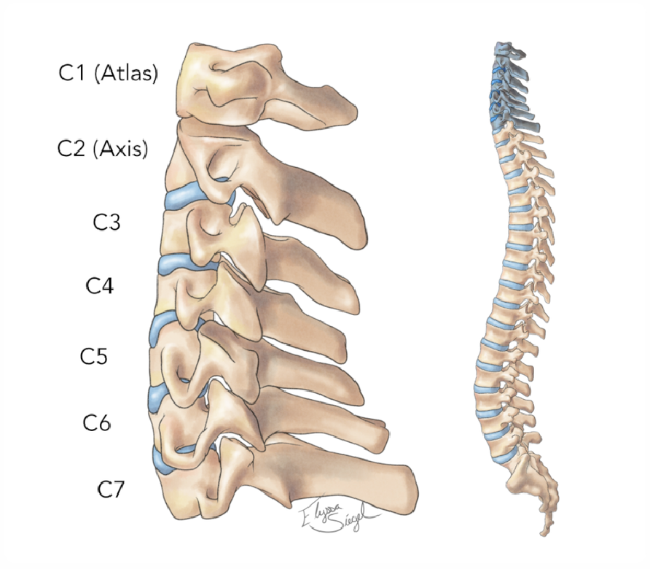

 Cervical spine anatomy

⚠

**High-energy trauma**

Clinical Significance: Cervical spine fracture or instability Action: Maintain immobilization during transport

⚠

**Neurological symptoms (weakness, numbness)**

Clinical Significance: Possible cord compression

Action: Document deficits, perform neurological assessment

⚠

**Systemic signs (fever, weight loss, cancer history)**

Clinical Significance: Possible infection or malignancy Action: Notify receiving hospital, document findings

⚠

**Headache with neurological deficits**

Clinical Significance: Stroke or mass lesion Action: Notify receiving facility, document deficits

⚠

**Fever with neck stiffness**

Clinical Significance: Meningitis

Action: Infection precautions, urgent transport

⚠

**Headache after trauma**

Clinical Significance: Subdural or epidural hematoma Action: Maintain c-spine precautions, rapid assessment

⚠ Early recognition of neurological emergencies saves lives

Paramedic Student Teaching Module

## Headache: Red Flags

Critical Warning Signs

⚠

**Sudden 'thunderclap' headache**

Clinical Significance: Subarachnoid hemorrhage Action: Initiate stroke alert, rapid transport

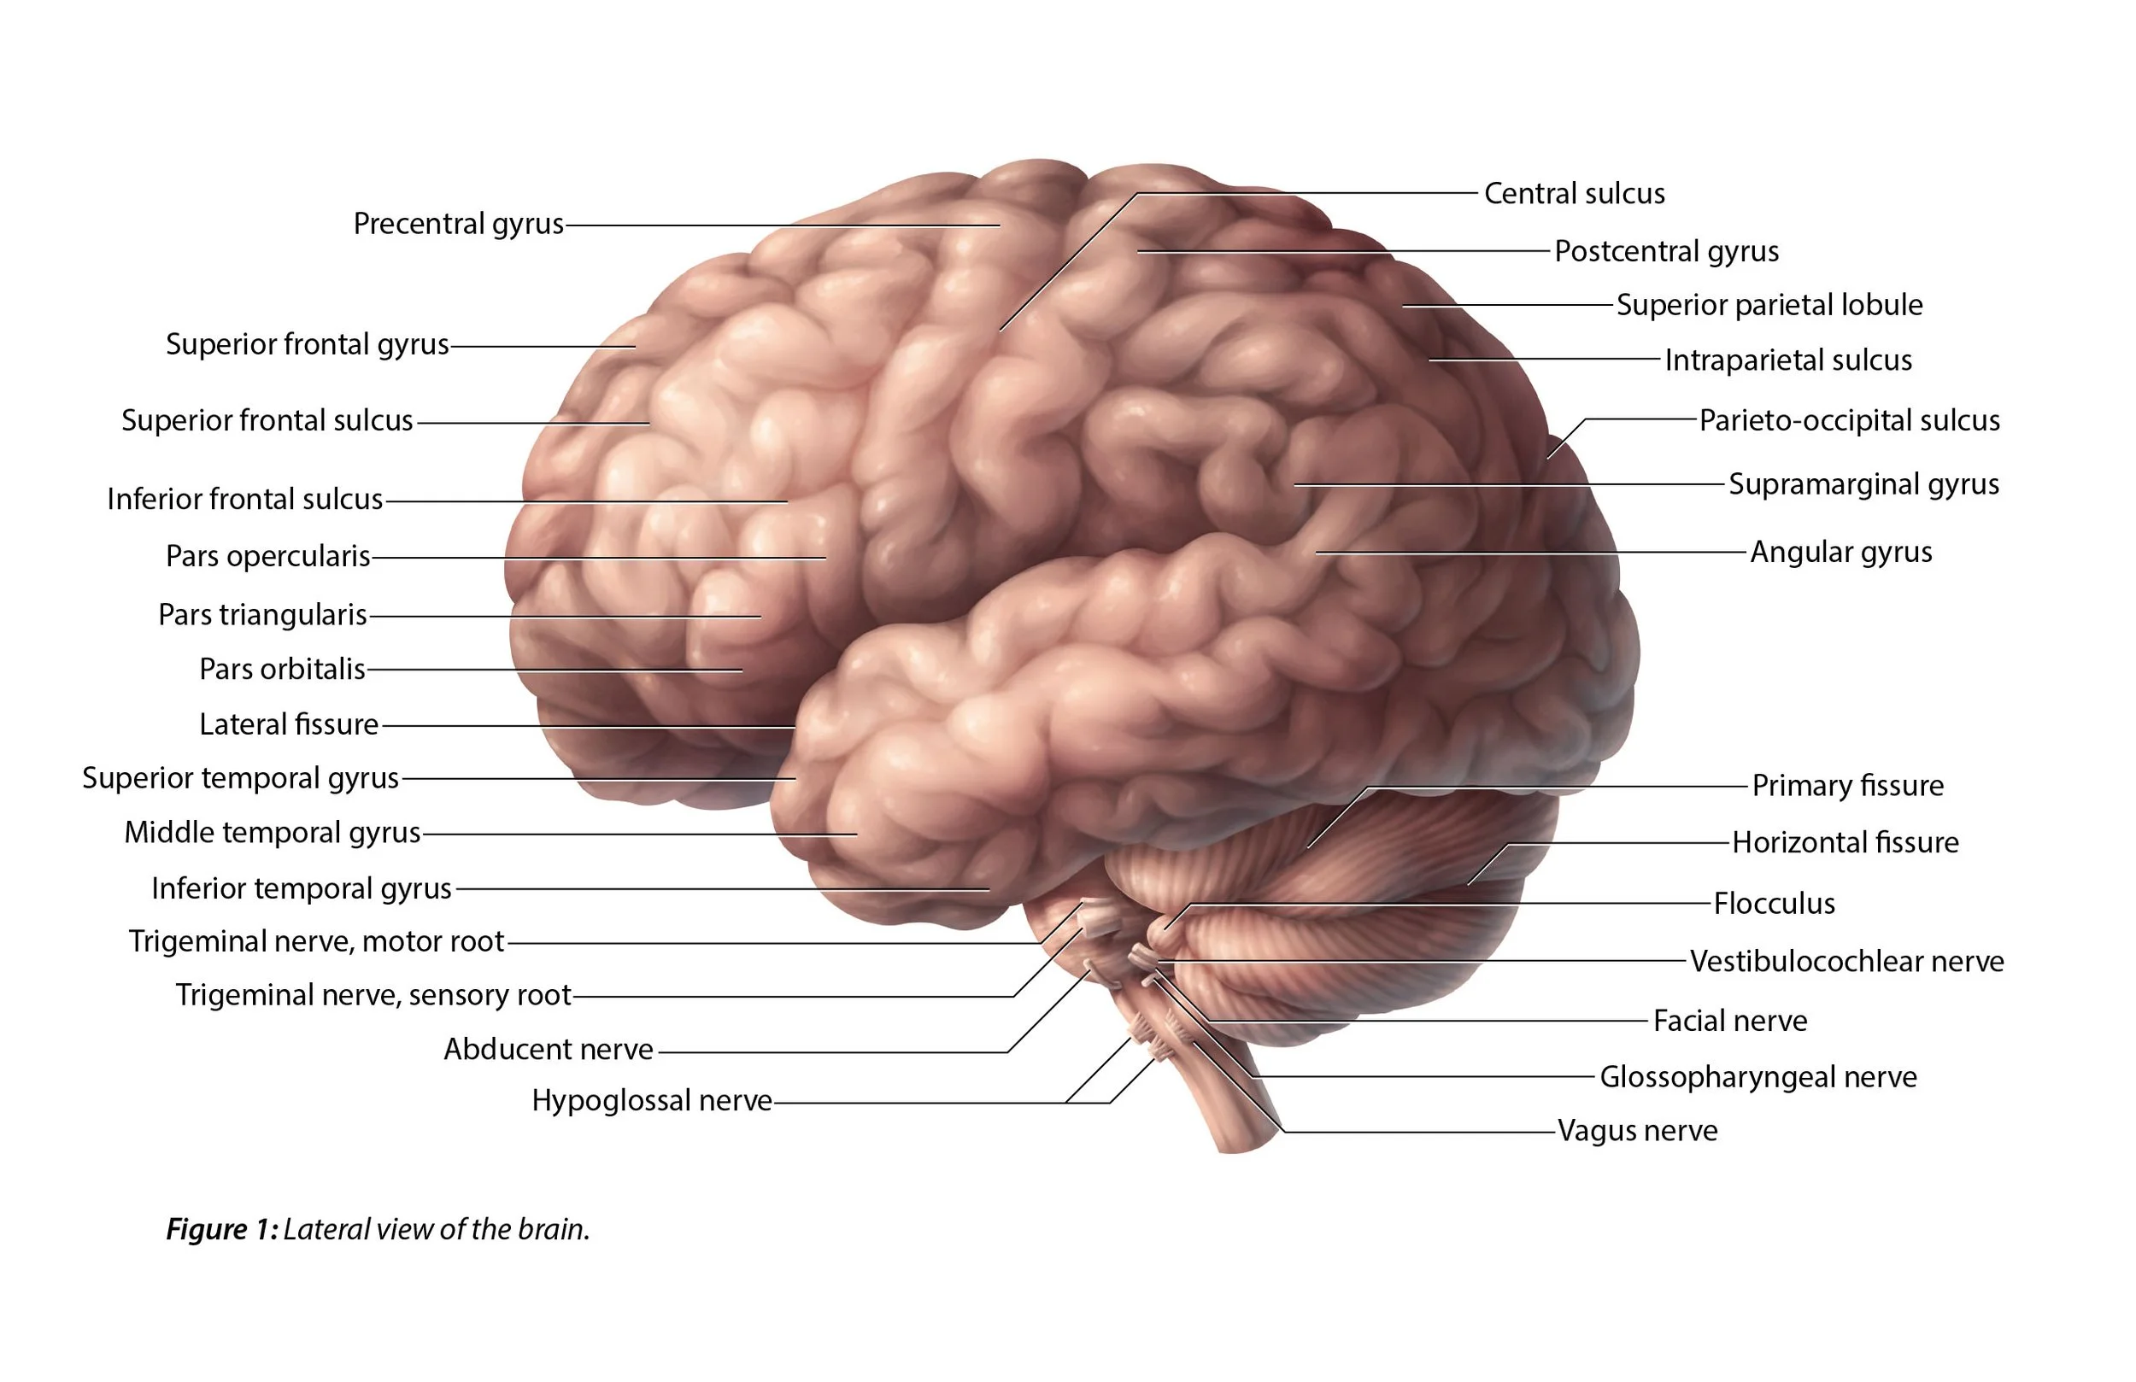

 Brain regions involved in headache mechanisms

⚠

**Crushing pain radiating to jaw/arm, diaphoresis, nausea**

Clinical Significance: STEMI (ST-Elevation Myocardial Infarction) Action: 12-lead ECG, administer aspirin, rapid transport

⚠

**Tearing chest pain radiating to back**

Clinical Significance: Aortic dissection

Action: Consider transport to tertiary care center

⚠

**Hypotension or syncope with chest pain**

Clinical Significance: Consider PE, MI, aortic dissection Action: Notify hospital, manage shock, prioritize transport

⚠

**Pain worse with exertion**

Clinical Significance: Angina/myocardial ischemia

Action: Monitor closely, obtain 12-lead, prepare for ACS protocols

⚠ Time-sensitive condition: Activate STEMI protocols when indicated

Paramedic Student Teaching Module

# Chest Pain: Red Flags

Critical Warning Signs

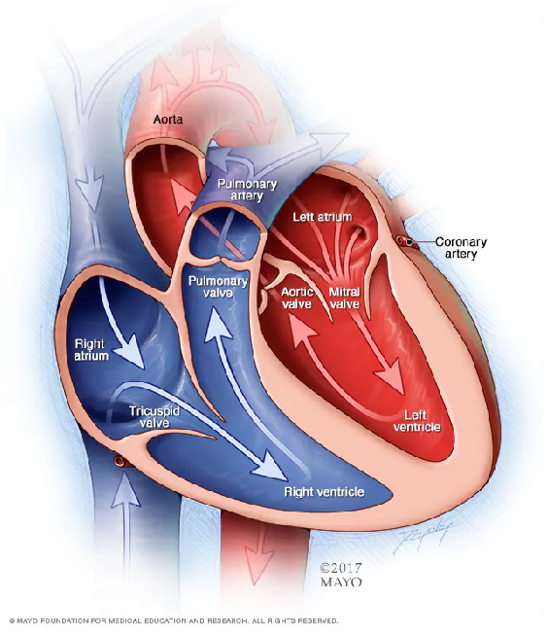

 Coronary arteries of the heart

⚠

**Rigid abdomen, rebound tenderness**

Clinical Significance: Peritonitis

Action: Surgical emergency, rapid transport

⚠

**AAA risk (older male, smoker, pulsatile mass, sudden severe pain)**

Clinical Significance: Suspect rupture Action: Manage shock, notify hospital

⚠

**Persistent vomiting**

Clinical Significance: Possible obstruction Action: Monitor fluids/electrolytes

⚠ Abdominal pain red flags frequently indicate surgical emergencies

Paramedic Student Teaching Module

# Abdominal Pain: Red Flags

Critical Warning Signs

⚠

**GI bleeding (hematemesis, melena)**

Clinical Significance: Hypovolemic shock risk Action: ABCs, IV access, transport

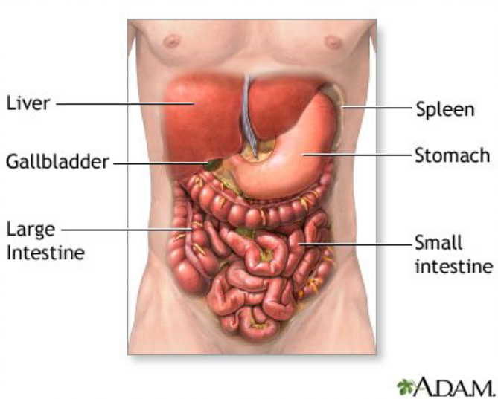

 Abdominal anatomy and organs

⚠

**Glucose abnormalities**

Always check glucose early!

Action: Immediate correction needed for hypo/hyperglycemia

⚠

**Head trauma/anticoagulant use with new AMS**

High risk for intracranial hemorrhage Action: Rapid transport, hospital notification

⚠

**Fever with AMS or meningismus**

Suspect meningitis or sepsis

Action: Infection precautions, urgent transport

⚠

**Seizure activity or prolonged post-ictal state**

Requires urgent intervention and hospital evaluation Action: Treat per protocol, monitor airway

⚠ Check glucose in all AMS patients - don't miss the obvious!

Paramedic Student Teaching Module - Part 1 of 2

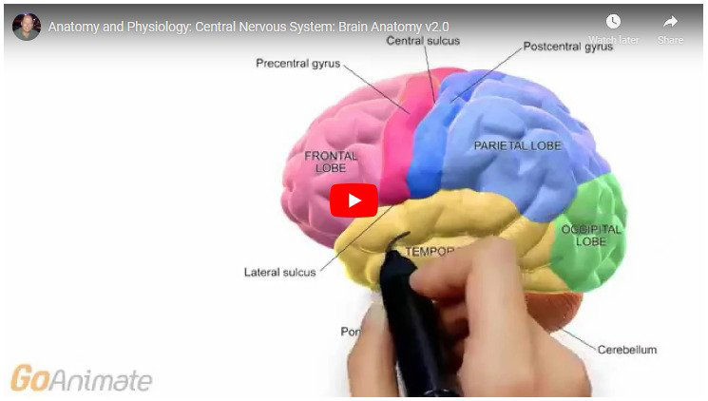

 Brain anatomy - AMS evaluation

## Altered Mental Status: Red Flags (Part 1)

Critical Warning Signs

⚠

**Toxidrome suspicion**

Signs: Overdose, pill bottles, drug paraphernalia, odors

Action: Treat per poison/toxicology protocols, consider Naloxone

⚠

**Sudden onset or rapid deterioration**

Clinical Significance: Suggests stroke, seizure, hypoglycemia, or toxic ingestion Action: Rapid identification and appropriate interventions

⚠

**Hemodynamic instability**

(hypotension, shock, weak pulses)

Clinical Significance: Consider sepsis, hemorrhage, cardiac causes

Action: Rapid transport and resuscitation

⚠

**Respiratory distress or hypoxia**

(bradypnea, hypoventilation, cyanosis, SpO₂ < 90%)

Clinical Significance: Life-threatening impaired oxygenation

Action: Provide oxygen and/or ventilation support immediately

⚠

**Airway compromise**

(inability to protect airway, gurgling, snoring, stridor)

Clinical Significance: Imminent risk of airway obstruction

Action: Urgent airway management required

⚠ AMS requires a disciplined, systematic approach due to broad differential

Paramedic Student Teaching Module



 Critical brain regions in AMS assessment

## Altered Mental Status: Red Flags (Part 2)

Critical Warning Signs (continued)

⚠

**Focal neurologic deficits**

(facial droop, weakness, unequal pupils, aphasia, abnormal posturing)

Clinical Significance: Possible stroke or intracranial hemorrhage

Action: Activate stroke alert; rapid transport

## Syncope Red Flags: Part 1

⚠

**Syncope in pregnancy**

Consider ectopic pregnancy or obstetric emergency

⚠

**GI bleeding with syncope**

High risk hypovolemia; manage fluid status

⚠

**Trauma or head strike**

Possible intracranial bleed/spine injury



**Initial Assessment**

Early recognition of these red flags enables rapid identification of serious causes of syncope requiring immediate intervention.



**Teaching Point**

See Part 2 for additional red flags including neurological deficits, prolonged LOC, cardiac history, and exertional syncope.

 Requires close monitoring and rapid transport

Paramedic Student Teaching Module

Critical Warning Signs

⚠

**Clustered recurrent episodes**

Serious underlying etiology likely

⚠

**Supine syncope or during sleep**

Suspicious for arrhythmia/cardiac cause

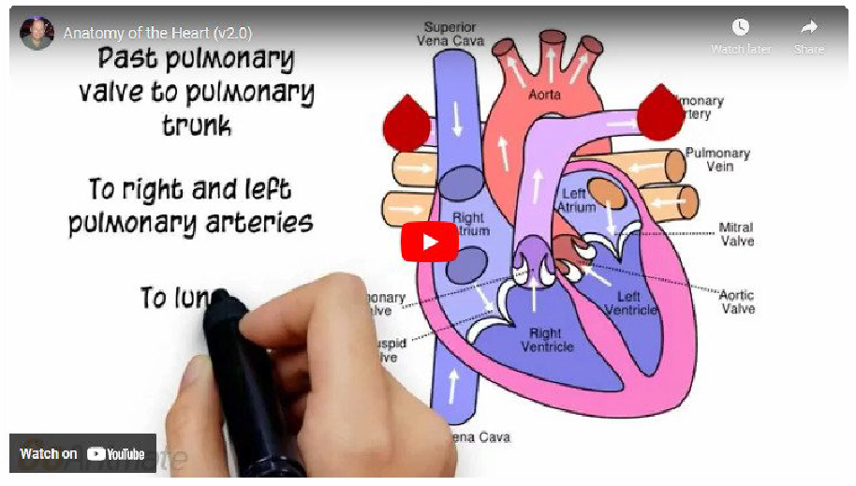

 Cardiovascular system assessment

⚠

**Hypotension/shock at scene**

Consider hemorrhage, arrhythmia, sepsis

⚠

**Prolonged LOC (>1–2 min) or post‑event confusion**

Clinical Significance: Seizure, intracranial hemorrhage Action: Detailed neurological exam, urgent transport

⚠

**Known cardiac disease or family history of sudden cardiac death**

Clinical Significance: High arrhythmic risk

Action: Cardiac monitoring, notify receiving facility

⚠

**Syncope with chest pain or palpitations**

Clinical Significance: Ischemia or tachy/bradyarrhythmia Action: 12-lead ECG, cardiac monitoring, rapid transport

⚠

**Exertional syncope or minimal/no prodrome**

Clinical Significance: Arrhythmia, structural heart disease, outflow obstruction Action: Priority transport to facility with cardiac capabilities

⚠ Syncope often points to cardiac, neurologic, or hemodynamic emergencies

Paramedic Student Teaching Module

## Syncope Red Flags: Part 2

Critical Warning Signs (continued)

⚠

**Focal neurological deficits after event**

Clinical Significance: Stroke/TIA Action: Consider stroke alert activation

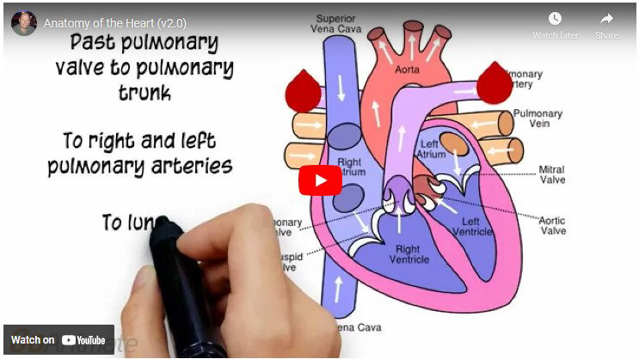

 Cardiovascular system assessment

# Key Takeaways & Critical Red Flags

 Trust your clinical judgment and don't hesitate to advocate for your patient

Paramedic Student Teaching Module



Early recognition improves outcomes & ensures hospital activation.

Paramedics must rapidly recognize red flags in the field.

Clinical Presentation Approach Clinical Presentation Approach



**Chest Pain & Headache**

Often require STEMI or stroke alerts; rapid recognition and hospital team activation



**Altered Mental Status**

Requires a disciplined, systematic approach due to broad differential; check glucose early



**Back & Neck Pain**

Usually recognition & documentation, not field intervention; immobilize when indicated



**Syncope**

Often points to cardiac, neurologic, or hemodynamic emergencies; close monitoring and rapid transport

⇨

**Abdominal Pain**

Frequently surgical emergencies; supportive care & transport; watch for rigid abdomen

**Critical Decision Points:**

 STEMI/stroke alerts for time-sensitive conditions

 Secure airway early when compromised

 Always check glucose in altered mental status





**Discussion Points**

* How does recognizing red flags change your treatment priorities?
* What hospital notifications would be appropriate for each case?

⇨ Practice recognizing patterns that indicate life-threatening conditions

Paramedic Student Teaching Module

# Case Studies: Identify the Red Flags

Review these scenarios and identify critical red flags that require immediate action



**Case 1: Back Pain**

Patient: 68-year-old female with history of breast cancer in

remission for 5 years

Complaint: Progressive lower back pain for 3 weeks, now with bilateral leg weakness and difficulty urinating

Critical Thinking: What red flags are present? What should your priority

actions be?

Hover for hint ↓



**Case 2: Altered Mental Status**

Patient: 24-year-old male found confused in apartment

Scene: Empty pill bottle nearby, diaphoretic, HR 120, BP 90/60, respirations shallow

Critical Thinking: What red flags are present? What are your immediate

priorities?

Hover for hint ↓



**Case 3: Headache**

Patient: 42-year-old male with "worst headache of my life"

Presentation: Sudden onset during workout, nausea, photophobia, slight confusion

Critical Thinking: What red flags are present? What hospital notification is

appropriate?

Hover for hint ↓



**Case 4: Abdominal Pain**

Patient: 76-year-old male with sudden severe abdominal pain

History: Smoker, hypertension. Pain radiates to back, abdomen feels "pulsating"

Critical Thinking: What life-threatening condition should you suspect?

Hover for hint ↓





**Key Discussion Points**

* Why does each case presentation require specific hospital notification or special transport considerations?
* How does early recognition of these specific red flags improve patient outcomes?

⇨ Critical red flags often point to time-sensitive emergencies requiring rapid intervention

Paramedic Student Teaching Module

# Case Studies: Part 2

Additional scenarios covering neck pain, chest pain, and syncope red flags



**Case 5: Neck Pain**

Patient: 22-year-old male involved in motorcycle collision

Presentation: Complains of neck pain, numbness and tingling in

both arms, unable to move fingers on left hand

Critical Thinking: What red flags are present? How should you manage this

patient?

Hover for hint ↓



**Case 6: Chest Pain**

Patient: 58-year-old female with sudden tearing chest pain radiating to back

Vitals: BP 190/110 (R arm), 150/90 (L arm), pulse 115, history of

hypertension

Critical Thinking: What red flags are present? What immediate concerns do

you have?

Hover for hint ↓



**Case 7: Syncope**

Patient: 19-year-old male basketball player collapsed during game

History: No prodromal symptoms, brief LOC, family history of "heart

problems"

Critical Thinking: What red flags are present? What is your transport

decision?

Hover for hint ↓



**Case 8: Syncope in Pregnancy**

Patient: 26-year-old female, 8 weeks pregnant with syncope and lower abdominal pain

Vitals: BP 88/60, HR 122, pale and diaphoretic, reports vaginal

spotting

Critical Thinking: What emergency condition is high on your differential

diagnosis?

Hover for hint ↓

# Quick Reference Card: Red Flags by System



**Cardiovascular Red Flags**

* **Crushing chest pain + radiation:** 12-lead ECG, aspirin, rapid transport
* **Hypotension with chest pain:** IV access, fluid bolus, hospital notification
* **Sudden dyspnea + chest pain:** Consider PE, high-flow O₂



**Respiratory Red Flags**

* **SpO₂ < 90%:** Immediate oxygen therapy
* **Stridor or gurgling:** Position airway, consider advanced management
* **Unequal breath sounds:** Consider pneumothorax, monitor closely



**Musculoskeletal Red Flags**

* **High-energy trauma:** Maintain spinal immobilization
* **Progressive neurological deficit:** Document, urgent transport
* **Saddle anesthesia:** Potential cauda equina, urgent recognition
* **Unexplained weight loss + pain:** Document, suspect malignancy

**Emergency Action Principles**

 Document red flags early in assessment

 Communicate findings clearly to receiving facility

 Prioritize rapid transport for time-sensitive conditions

 Trust your assessment skills and clinical judgment

 When in doubt, transport to the appropriate facility and provide early notification

Paramedic Student Teaching Module



**Neurological Red Flags**

* **Thunderclap headache:** Rapid transport, stroke alert
* **Focal deficits:** Document, notify receiving facility
* **Neck stiffness + fever:** Infection precautions, urgent transport
* **Altered mental status:** Check glucose, assess airway

**Abdominal Red Flags**

* **Rigid abdomen/rebound:** Surgical emergency, rapid transport
* **GI bleeding:** Large-bore IV access, fluid resuscitation
* **Pulsatile mass + pain:** Suspect AAA, gentle handling, rapid transport
* **Persistent vomiting:** IV fluids, antiemetics, monitor electrolytes

♥

**Thank You**

For your dedication to excellence in emergency medical care and patient safety

 Remember: Early recognition saves lives

Paramedic Student Teaching Module | September 2025

✶

**Online Resources**

1. Emergency Medicine Practice
2. UpToDate Clinical Database
3. FOAM (Free Open Access Medical Education)

✉

**Contact & Support**

For questions about this training module or to request additional

resources, please contact the EMS Education Department.

 ems.education@ example.org

## Resources & Acknowledgments

**Recommended Resources Acknowledgments**

−

**Clinical References**

1. Paramedic Care: Principles & Practice
2. Tintinalli's Emergency Medicine
3. EMS Field Guide



**Contributors**

This training module was developed in collaboration with

emergency medicine physicians, experienced paramedics, and EMS educators to provide evidence-based guidance for field assessment.